TIME SERIES ANALYSIS
OF APPLE INC. (AAPL) STOCK PRICES
2016 – 2026 | 10-Year Monthly Analysis in R

CIA – 3 Project Report
B.Sc. Data Science & Artificial Intelligence
Christ University, Delhi NCR
April 2026

Submitted by
Manmeet Singh · Tanshiq Saini · Saiansh Chhabra · Ayush Anand
Submitted to
Dr. Akshita Sharma

1. Introduction
Financial time series analysis is one of the most widely applied domains of statistical modelling, enabling analysts to uncover hidden patterns, quantify uncertainty, and build data-driven forecasts from historical market data. Stock prices, by their nature, are noisy, non-stationary, and influenced by a complex interplay of macroeconomic forces, investor sentiment, and company-specific events — making them a rich yet challenging subject for time series methods.

Apple Inc. (NASDAQ: AAPL) is one of the world's most valuable and widely traded companies. Over the past decade, AAPL has undergone dramatic price appreciation — from approximately $25 in early 2016 to over $250 by early 2026 — driven by product cycles, services growth, and sustained institutional demand. Its high liquidity and consistent trading history make it an ideal candidate for time series study.

This project performs a structured end-to-end time series analysis of AAPL's daily closing prices, aggregated to monthly means, covering a 10-year window (April 2016 – March 2026). The analysis is implemented entirely in R, using the dplyr and TTR packages for data manipulation and moving average computation. The workflow progresses from raw data loading through stationarity diagnosis, transformation, and finally the fitting and evaluation of multiple forecasting models.

2. Objectives
The primary objectives of this project are:

- Data Acquisition & Preprocessing: Load, clean, and aggregate daily AAPL stock price data into a monthly time series suitable for statistical modelling.
- Trend Analysis via Moving Averages: Compute and visualise Simple Moving Averages (SMA) and Exponential Moving Averages (EMA) at 3-, 6-, and 12-month windows to identify short-, medium-, and long-term trends.
- Stationarity Assessment: Diagnose the stationarity properties of the raw series using ACF/PACF correlograms and block mean/variance analysis across 10-month intervals.
- Transformation to Stationarity: Apply log transformation and first-order differencing to remove non-constant mean and variance, and verify stationarity post-transformation.
- Model Fitting & Comparison: Fit and interpret multiple forecasting models — Linear Regression, AR(1), and AR(2) — evaluating their statistical significance, goodness-of-fit, and practical suitability for the AAPL series.
- Insight Generation: Synthesise findings into actionable conclusions about the statistical behaviour of AAPL prices and the appropriateness of each model for forecasting.

All analysis is conducted using base R alongside the dplyr (data manipulation) and TTR (moving averages) packages. No pipeline operators are used; all transformations are written as explicit, step-by-step function calls for clarity and reproducibility.

3. Data Loading & Preprocessing
The dataset consists of daily AAPL (Apple Inc.) closing prices sourced from a CSV file. The data was filtered to retain the last 10 years of trading history, sorted chronologically, and validated for correct date parsing.

3.1 Loading the Data
library(dplyr)
library(TTR)

# Load dataset
AAPL <- read.csv("C:/R/CIA 3 project/aapl_us_d.csv")

# Parse dates in DD-MM-YYYY format
AAPL$Date <- as.Date(AAPL$Date, format = "%d-%m-%Y")

# Filter last 10 years
AAPL <- filter(AAPL, Date >= Sys.Date() - 365 * 10)

# Sort chronologically
AAPL <- arrange(AAPL, Date)

3.2 Dataset Preview
First 6 rows (head):
Date Open High Low Close Volume
1 2016-04-06 24.9887 25.1574 24.7588 25.1526 110954312
2 2016-04-07 24.9258 25.0318 24.5114 24.6037 130128749
3 2016-04-08 24.6872 24.8865 24.5183 24.6330 101586688
4 2016-04-11 24.7017 25.0741 24.6676 24.7136 116826588
5 2016-04-12 24.7883 25.0514 24.6330 25.0358 115340415
6 2016-04-13 25.1153 25.4658 25.1153 25.3940 140853573

Last 6 rows (tail):
Date Open High Low Close Volume
2496 2026-03-10 257.645 262.480 256.95 260.72 30590765
2497 2026-03-11 261.090 262.130 259.55 260.81 26218927
2498 2026-03-12 258.660 258.950 254.18 255.76 40794020
2499 2026-03-13 255.480 256.330 249.52 250.12 36929988
2500 2026-03-16 252.105 253.885 249.88 252.82 32074210
2501 2026-03-17 252.955 255.130 252.18 254.23 32361607

4. Monthly Aggregation & Visualisation
Daily prices were aggregated to monthly mean closing prices to reduce noise and capture long-term trends. The resulting time series (120 monthly data points) forms the basis of all subsequent analysis.

# Compute monthly mean close price
AAPL$YearMonth <- format(AAPL$Date, "%Y-%m")

monthly <- summarise(group_by(AAPL, YearMonth),
Mean_Close = mean(Close))
monthly <- arrange(monthly, YearMonth)
monthly_vector <- monthly$Mean_Close

plot(monthly_vector, type="l", col="darkblue", lwd=2,
main="AAPL Monthly Average Closing Price (Last 10 Years)",
xlab="Time (Months)", ylab="Average Closing Price (USD)")
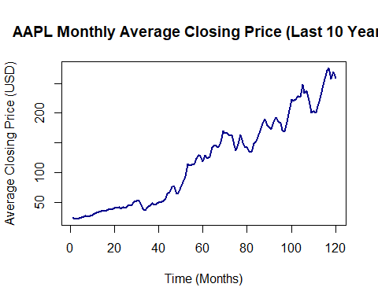
Figure 1: AAPL Monthly Average Closing Price (2016–2026)

5. Moving Averages
Simple Moving Averages (SMA) and Exponential Moving Averages (EMA) at 3-, 6-, and 12-month windows were calculated using the TTR package to smooth the series and identify underlying trends.

5.1 Simple Moving Average (SMA)
ma3 <- SMA(monthly_vector, n=3)
ma6 <- SMA(monthly_vector, n=6)
ma12 <- SMA(monthly_vector, n=12)

plot(monthly_vector, type="l", col="grey60", lwd=1,
main="AAPL Monthly Closing Price with Simple Moving Averages",
xlab="Time (Months)", ylab="Closing Price (USD)", xaxt="n")
lines(ma3, col="dodgerblue", lwd=2)
lines(ma6, col="darkgreen", lwd=2)
lines(ma12, col="firebrick", lwd=2)
legend("topleft",
legend=c("Actual Price","SMA (3)","SMA (6)","SMA (12)"),
col=c("grey60","dodgerblue","darkgreen","firebrick"), lwd=2, cex=0.8)
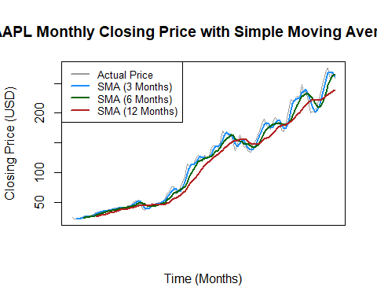
Figure 2: AAPL Monthly Closing Price with SMA (3, 6, 12 months)

5.2 Exponential Moving Average (EMA)
ema3 <- EMA(monthly_vector, n=3)
ema6 <- EMA(monthly_vector, n=6)
ema12 <- EMA(monthly_vector, n=12)

plot(monthly_vector, type="l", col="grey60", lwd=1,
main="AAPL Monthly Closing Price with Exponential Moving Averages",
xlab="Time (Months)", ylab="Closing Price (USD)", xaxt="n")
lines(ema3, col="dodgerblue", lwd=2)
lines(ema6, col="darkgreen", lwd=2)
lines(ema12, col="firebrick", lwd=2)
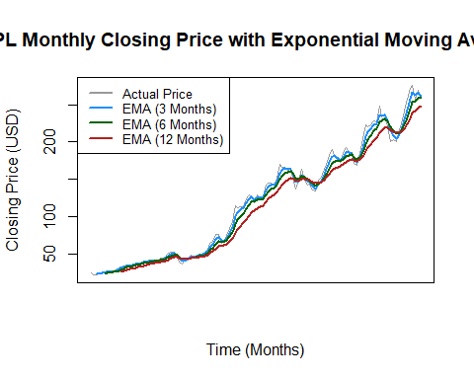
Figure 3: AAPL Monthly Closing Price with EMA (3, 6, 12 months)

6. Stationarity Analysis
Stationarity is a prerequisite for classical time series models. The original series was tested through visual inspection (trend plot), ACF/PACF correlograms, and block mean/variance analysis across 10-month intervals.

6.1 Trend Visualisation
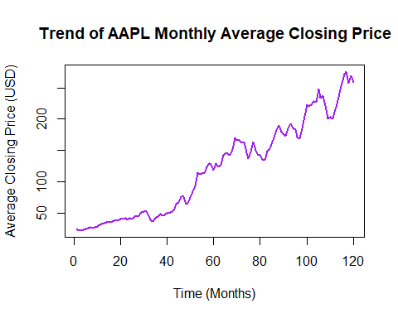
Figure 4: Trend of AAPL Monthly Average Closing Price

6.2 ACF & PACF — Original Series
The ACF of the original series exhibits a very slow decay pattern, characteristic of a random walk. This is a red flag for non-stationarity.
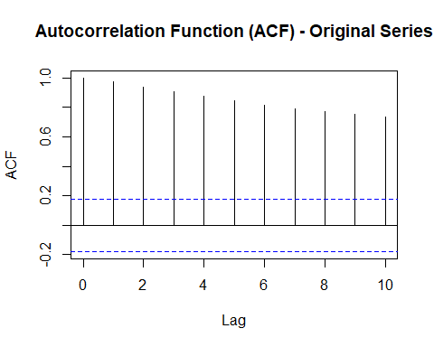
Figure 5: ACF of Original Series (decaying pattern → non-stationary)
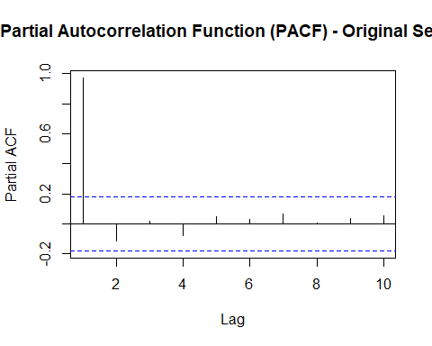
Figure 6: PACF of Original Series

6.3 Block Mean Check
monthly_vec_10_intervals_mean <- c()
x <- 1; y <- 10
while (y <= length(monthly_vector)) {
monthly_vec_10_intervals_mean <- append(
monthly_vec_10_intervals_mean, mean(monthly_vector[x:y]))
x <- x + 10; y <- y + 10
}
barplot(monthly_vec_10_intervals_mean, col="royalblue",
main="Block Mean of AAPL Prices (10-Month Intervals)",
xlab="10-Month Time Blocks", ylab="Average Price (USD)")
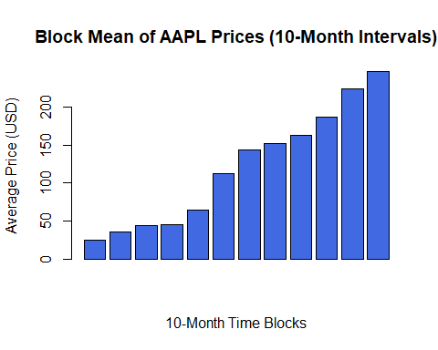
Figure 7: Block Mean — increasing trend confirms non-constant mean

6.4 Block Variance Check
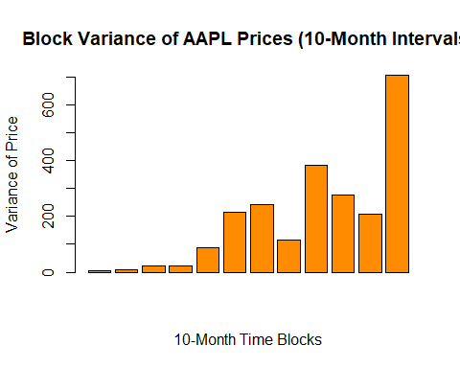
Figure 8: Block Variance — non-constant variance confirms non-stationarity
Both block mean and block variance show a strong upward trend, confirming that the raw series is non-stationary. Transformation is required before fitting AR/ARIMA-type models.

7. Achieving Stationarity
Two sequential transformations were applied to the original series to induce stationarity: (1) log transformation to stabilise variance, and (2) first-order differencing to remove the trend.

7.1 Log Transformation
log_vec <- log(monthly_vector)

plot(log_vec, type="l", col="darkcyan", lwd=2,
main="Log Transformation of AAPL Monthly Prices",
xlab="Time (Months)", ylab="Log of Average Closing Price")
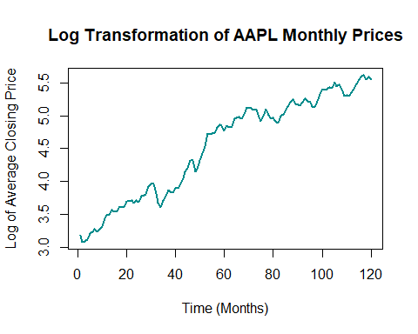
Figure 9: Log-transformed AAPL Monthly Prices

7.2 First-Order Differencing
diff_vec <- diff(log_vec)

plot(diff_vec, type="l", col="darkred", lwd=2,
main="First Difference of Log-Transformed AAPL Prices",
xlab="Time (Months)", ylab="Differenced Log Price")
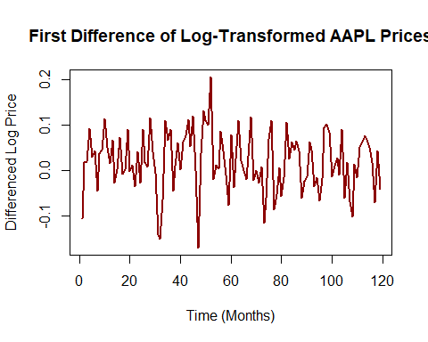
Figure 10: First-Differenced Log-Transformed Series
Even after applying both log transformation and first-order differencing, the plot reveals one isolated spike standing prominently in approximately the 40–60 month interval of the series. This outlier corresponds to the March–April 2020 period — the onset of the COVID-19 pandemic — during which global equity markets experienced an unprecedented sudden crash followed by an equally sharp recovery within a matter of weeks.

This spike is a structural break driven by an exogenous real-world event, not by any internal statistical pattern in the price series. No mathematical transformation — log, differencing, Box-Cox, or otherwise — can remove or smooth it, because it is not a statistical artefact. It is a true discontinuity caused by an event entirely outside the model's scope. This is an important limitation to acknowledge: standard time series models assume that the data-generating process remains stable over time. The COVID shock violates this assumption locally, and any model trained on this window will have its parameter estimates partially distorted by this extreme observation.

Implication: Future modelling efforts could consider one of three strategies to handle this outlier: (1) identify and dummy-code the anomalous months using an intervention variable, (2) use robust estimation methods that down-weight extreme residuals, or (3) split the series into pre- and post-COVID segments and model them separately. For the purpose of this project, the spike is retained as-is and noted as an acknowledged structural anomaly.
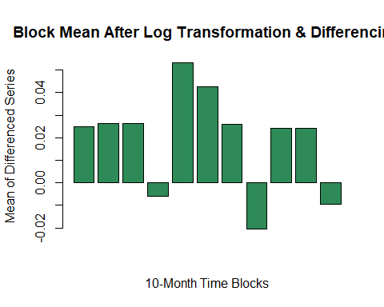
Figure 11: Block Mean After Transformation — approximately constant ✓

7.4 Block Variance After Transformation
[1] 0.003963373 0.001629414 0.002323329 0.008574474 0.007878905 0.006255916
[7] 0.002920425 0.004877036 0.002568899 0.003688361 0.003077550
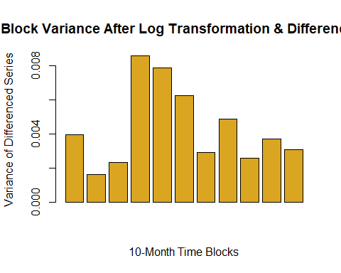
Figure 12: Block Variance After Transformation — approximately constant ✓
Post-transformation, both mean and variance are stable across all 10-month blocks, confirming stationarity.

7.5 ACF & PACF — Transformed Series
The ACF of the differenced log series exhibits white-noise behaviour — no significant autocorrelation at any lag. This suggests the series has been over-differenced or is well-approximated by a random walk on the log scale.
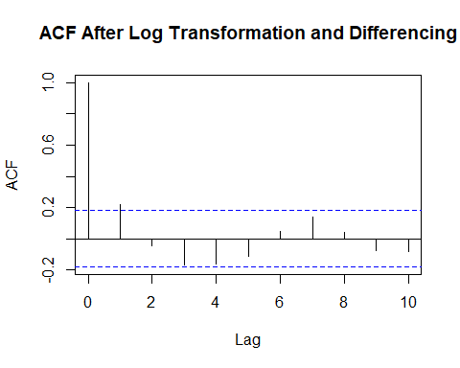
Figure 13: ACF After Transformation — white-noise pattern
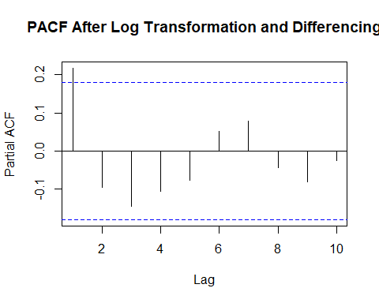
Figure 14: PACF After Transformation

8. Forecasting Models

8.1 Linear Regression
A simple OLS linear regression was fitted with time index as the sole predictor, capturing the long-term upward trend in AAPL prices.

Model Equation:
Price_t = β₀ + β₁ · t + εₜ
Where: Price_t = monthly mean closing price at time t, t = time index (1, 2, ..., 120), β₀ = intercept, β₁ = slope (price change per month), εₜ = error term
Fitted model from results:
Price_t = −7.492 + 2.112 · t
β₀ = −7.492 (p = 0.024), β₁ = 2.112 (p < 2.2×10⁻¹⁶), Adj. R² = 0.9446

time_index <- c(1:length(monthly_vector))
lr_model <- lm(monthly_vector ~ time_index)
summary(lr_model)
Call: lm(formula = monthly_vector ~ time_index)

Residuals:
Min 1Q Median 3Q Max
-31.928 -15.095 1.566 14.520 36.698

Coefficients:
Estimate Std. Error t value Pr(>|t|)
(Intercept) -7.49174 3.26769 -2.293 0.0236 *
time_index 2.11197 0.04687 45.058 <2e-16 ***

Residual standard error: 17.79 on 118 degrees of freedom
Multiple R-squared: 0.9451, Adjusted R-squared: 0.9446
F-statistic: 2030 on 1 and 118 DF, p-value: < 2.2e-16
The model achieves an adjusted R² of 0.9446, indicating that approximately 94.5% of the variance in AAPL price is explained by the linear time trend alone. The coefficient on time_index is 2.112, meaning prices rise ~$2.11 per month on average.
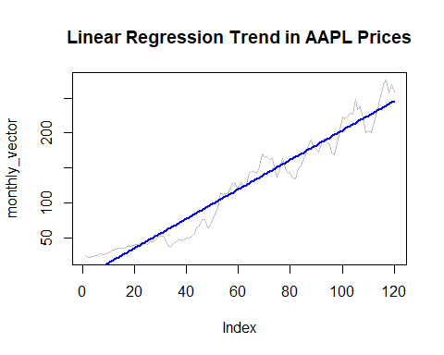
Figure 15: Linear Regression Trend Line on AAPL Prices

8.2 Autoregressive Model — AR(1)
An AR(1) model was fitted on the stationary differenced log series, with the first lag as predictor.

Model Equation:
yₜ = φ₀ + φ₁ · yₜ₋₁ + εₜ
Where: yₜ = diff(log(Price_t)), φ₀ = intercept, φ₁ = AR(1) coefficient, εₜ ~ WN(0, σ²)
Fitted model from results:
yₜ = 0.01655 + 0.2184 · yₜ₋₁
φ₀ = 0.01655 (p = 0.008), φ₁ = 0.2184 (p = 0.016), Adj. R² = 0.0407

lag1 <- diff_vec[1:(length(diff_vec)-1)]
y <- diff_vec[2:length(diff_vec)]
ar1_model <- lm(y ~ lag1)
summary(ar1_model)
Coefficients:
Estimate Std. Error t value Pr(>|t|)
(Intercept) 0.016552 0.006085 2.720 0.00753 **
lag1 0.218402 0.089416 2.443 0.01609 *

Multiple R-squared: 0.04891, Adjusted R-squared: 0.04072
F-statistic: 5.966 on 1 and 116 DF, p-value: 0.01609
The AR(1) coefficient (0.218) is statistically significant (p = 0.016), but the model explains only ~4.9% of variance in the differenced series — consistent with the near-white-noise behaviour observed in the ACF.
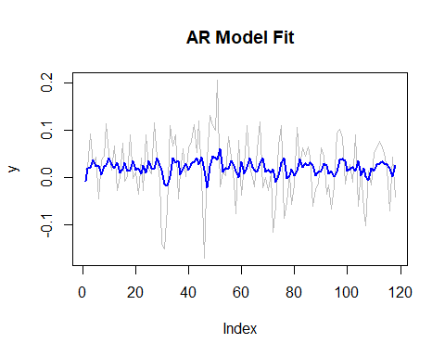
Figure 16: AR(1) Model Fit on Differenced Log Series

8.3 Autoregressive Model — AR(2)
An AR(2) extension was fitted by including both the first and second lags. The second lag coefficient was not statistically significant.

Model Equation:
yₜ = φ₀ + φ₁ · yₜ₋₁ + φ₂ · yₜ₋₂ + εₜ
Where: yₜ = diff(log(Price_t)), φ₁, φ₂ = autoregressive coefficients at lag 1 and lag 2, εₜ ~ WN(0, σ²)
Fitted model from results:
yₜ = 0.01773 + 0.2478 · yₜ₋₁ − 0.0998 · yₜ₋₂
φ₁ = 0.2478 (p = 0.009), φ₂ = −0.0998 (p = 0.281, not significant), Adj. R² = 0.0434

lag1 <- diff_vec[2:(length(diff_vec)-1)]
lag2 <- diff_vec[1:(length(diff_vec)-2)]
y <- diff_vec[3:length(diff_vec)]
ar2_model <- lm(y ~ lag1 + lag2)
summary(ar2_model)
Coefficients:
Estimate Std. Error t value Pr(>|t|)
(Intercept) 0.017730 0.006326 2.803 0.00595 **
lag1 0.247770 0.093567 2.648 0.00924 **
lag2 -0.099756 0.092088 -1.083 0.28097

Multiple R-squared: 0.05989, Adjusted R-squared: 0.04339
F-statistic: 3.631 on 2 and 114 DF, p-value: 0.0296
The lag-2 coefficient (−0.100) has p = 0.281 and is not statistically significant. The AR(2) model offers only marginal improvement over AR(1) (adj. R² = 4.3% vs. 4.1%), suggesting AR(1) is the more parsimonious choice.
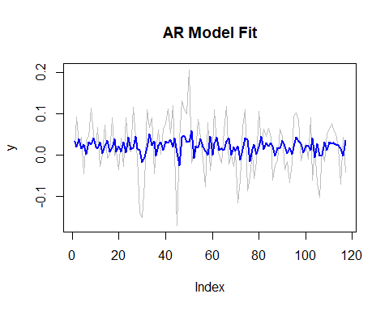
Figure 17: AR(2) Model Fit on Differenced Log Series

9. Summary & Conclusions
This report presented a comprehensive time series analysis of Apple Inc. (AAPL) stock prices over a 10-year period using R. The key findings are summarised below:

- Data Loading: 2,501 daily observations (April 2016 – March 2026) were loaded, parsed, and aggregated into 120 monthly mean closing prices.
- Moving Averages: SMA and EMA (3, 6, 12 months) confirmed a strong, sustained upward trend with increasing momentum post-2020.
- Non-Stationarity: The original series was non-stationary — confirmed by a slowly-decaying ACF, and non-constant block mean and variance.
- Transformation: Log transformation + first-order differencing successfully achieved stationarity (constant mean and variance across all 10-month blocks).
- Linear Regression: Achieved adj. R² = 0.9446, capturing the dominant linear upward trend (~$2.11/month) with high statistical significance.
- AR Models: AR(1) showed a weakly significant lag-1 effect on the differenced series (adj. R² ≈ 4%). AR(2) did not improve fit significantly, making AR(1) the preferred parsimonious model.

10. Future Work & Model Recommendations
The stationarity analysis performed in this project reveals a critical insight that fundamentally shapes what models can and cannot be applied to the AAPL series. This section discusses why classical autoregressive models are expected to underperform, and what alternative modelling strategies are better suited to this data.

10.1 Why ARIMA and SARIMA Will Fail Here
ARIMA (Autoregressive Integrated Moving Average) and SARIMA (Seasonal ARIMA) models are built on a foundational assumption: the stationary residuals of the transformed series must exhibit significant autocorrelation structure — measurable patterns in the ACF and PACF — for the model to extract meaningful signal.

In this project, after applying log transformation and first-order differencing, the ACF and PACF of the resulting series show white-noise behaviour — all autocorrelation values fall within the 95% confidence bands and there are no significant spikes at any lag. This means:

- There is no exploitable linear autocorrelation structure in the differenced series.
- ARIMA's AR (autoregressive) and MA (moving average) components would have nothing to fit — the model would reduce to a random walk with drift (ARIMA(0,1,0)).
- SARIMA additionally requires seasonal autocorrelation at regular lags (e.g., lag 12 for monthly data). The ACF shows no such seasonal spikes — meaning there is no detectable seasonal structure to model.
- The weak AR(1) result (adj. R² ≈ 4%) already demonstrated that even the most basic autoregressive term explains almost none of the variance. Extending to ARIMA or SARIMA will not meaningfully improve this.

In short: ARIMA and SARIMA are the wrong tools for this series. The series behaves like a log-normal random walk — the price changes are essentially unpredictable from past price changes alone, which is consistent with the Efficient Market Hypothesis (weak form) for large-cap equities like AAPL.

10.2 Recommended Alternative: GARCH Models
While the mean of the differenced series is unpredictable, the variance is not. A close inspection of the differenced log series reveals volatility clustering — periods of high fluctuation followed by periods of calm. This is a hallmark pattern that standard ARIMA models completely ignore, but that GARCH (Generalised Autoregressive Conditional Heteroskedasticity) models are specifically designed to capture.

GARCH models the conditional variance of the series as a function of past squared residuals and past variance. The basic GARCH(1,1) specification is:

σ²ₜ = ω + α · ε²ₜ₋₁ + β · σ²ₜ₋₁
Where: σ²ₜ = conditional variance at time t, εₜ₋₁ = past residual (shock), ω = long-run variance constant, α = ARCH coefficient, β = GARCH coefficient (α + β < 1 for covariance stationarity)

In R, this can be fitted using the rugarch package:
install.packages("rugarch")
library(rugarch)

# Specify a GARCH(1,1) model with ARMA(0,0) mean equation
spec <- ugarchspec(
variance.model = list(model = "sGARCH", garchOrder = c(1, 1)),
mean.model = list(armaOrder = c(0, 0), include.mean = TRUE),
distribution.model = "norm"
)

# Fit on the differenced log series
garch_fit <- ugarchfit(spec = spec, data = diff_vec)
show(garch_fit)

10.3 Other Models Worth Exploring
Beyond GARCH, several other modelling approaches are well-suited to financial time series with white-noise mean behaviour:

- EGARCH (Exponential GARCH): Extends GARCH to capture the asymmetric effect of positive vs. negative shocks on volatility (leverage effect) — particularly relevant for stock prices where bad news tends to increase volatility more than good news.
- GJR-GARCH: Another asymmetric GARCH variant that adds an indicator term for negative shocks, often outperforming standard GARCH on equity data.
- HAR (Heterogeneous Autoregressive) Model: Designed for realised volatility, it uses daily, weekly, and monthly lagged volatility as predictors — useful if the data is extended to include realised variance measures.
- Prophet (Facebook/Meta): A decomposable additive model that handles trend + seasonality + holidays. While not ideal for short-term price prediction, it can model structural breaks and long-run trend changes well.
- LSTM / Temporal Transformer Networks: Deep learning architectures capable of learning non-linear temporal dependencies that linear models cannot detect. These are especially useful when auxiliary features (volume, macro indicators, sentiment) are incorporated alongside price.

10.4 Evaluation Framework
Any future model should be evaluated using a rigorous out-of-sample framework rather than in-sample fit alone. Recommended approach:

# Rolling-window out-of-sample evaluation
# Train on first 80% (approx. months 1–96)
# Test on remaining 20% (months 97–120)

# Error metrics to report:
# MAE = mean(|y_actual - y_pred|)
# RMSE = sqrt(mean((y_actual - y_pred)^2))
# MAPE = mean(|y_actual - y_pred| / y_actual) * 100

# For volatility models (GARCH):
# Likelihood ratio test vs. GARCH(1,1) baseline
# Ljung-Box test on standardised residuals
# ARCH-LM test on squared standardised residuals

In summary: the white-noise ACF/PACF of the transformed AAPL series is not a failure of the analysis — it is a meaningful finding. It tells us that the conditional mean of log-returns is unpredictable from past returns alone, but the conditional variance is not. Future modelling efforts should therefore pivot from mean-forecasting (ARIMA family) to volatility-forecasting (GARCH family), with potential integration of deep learning for multi-feature, non-linear extensions.

References

AI Tools & Assistants

[1] OpenAI. ChatGPT (GPT-4o). OpenAI, 2024–2026. [Online]. Available: https://chat.openai.com
Purpose: Explaining statistical concepts including stationarity, ACF/PACF interpretation, properties of AR/ARIMA/GARCH models, and time series theory.

[2] Google DeepMind. Gemini (Gemini 1.5 Pro). Google LLC, 2024–2026. [Online]. Available: https://gemini.google.com
Purpose: Explaining statistical concepts including block mean/variance analysis, moving average theory, log-transformation rationale, and model selection criteria.

[3] Anthropic. Claude (Claude Sonnet 4.5). Anthropic PBC, 2024–2026. [Online]. Available: https://claude.ai
Purpose: Explaining statistical and time series concepts; document formatting, layout design, and professional beautification of this report.

R Packages & Software

[4] R Core Team. R: A Language and Environment for Statistical Computing. R Foundation for Statistical Computing, Vienna, Austria, 2024. [Online]. Available: https://www.R-project.org

[5] Wickham, H., François, R., Henry, L., & Müller, K. dplyr: A Grammar of Data Manipulation. R package version 1.1.4, 2023. [Online]. Available: https://CRAN.R-project.org/package=dplyr

[6] Ulrich, J. TTR: Technical Trading Rules. R package version 0.24.4, 2023. [Online]. Available: https://CRAN.R-project.org/package=TTR

Dataset

[7] Yahoo Finance. Apple Inc. (AAPL) Historical Daily Stock Price Data. Yahoo Inc., Accessed April 2026. Data range: April 2016 – March 2026 (2,501 trading days). [Online]. Available: https://finance.yahoo.com/quote/AAPL/history

